**NETWORKING PRINCIPLES LAB MANUAL 1**

Networking is at the heart of the digital transformation. The network is essential to many business functions today, including business critical data and operations, cybersecurity, and so much more. A wide variety of career paths rely on the network—so it’s important to understand what the network can do, how it operates, and how to protect it.

This is a great course for developers, data scientists, cybersecurity specialists, and other professionals looking to broaden their networking domain knowledge. It’s also an excellent launching point for students pursuing a wide range of career pathways—from cybersecurity to software development to business and more.

You’ll learn these core skills:

* Plan and install a home or small business network using wireless technology, then connect it to the Internet.
* Develop critical thinking and problem-solving skills using Cisco Packet Tracer.
* Practice verifying and troubleshooting network and Internet connectivity.
* Recognize and mitigate security threats to a home network.

These Lab Manuals provide you with all the labs and packet tracer activity instructions from the course designed as hands-on practice to develop critical thinking and complex problem-solving skills.

**Lab Instructions:**

1. Attendance at all labs is mandatory.
2. Sharing of “check-in code” or checking without attending the lab is strictly prohibited.
3. Adhere to both the instructions provided in the lab manual and those given by the instructor.
4. Seek assistance from your instructor if you require help or clarification.
5. All students need to present their answers to the lab instructor before the end of the lab.
6. NOTE: Successful completion of the online short course "[Getting Started with Cisco Packet Tracer"](https://skillsforall.com/course/getting-started-cisco-packet-tracer?utm_source=netacad.com&utm_medium=referral&utm_campaign=packet-tracer&courseLang=en-US&userlogin=0) is a prerequisite for the upcoming lab (the 2nd lab). Please make sure you have finished the short course before the next lab. Additionally, students are required to present the earned badge to their instructor before commencing the lab.

# Lab 1 – Part A - My Local Network

## Objectives

* Record all the different network attached devices in your home or classroom.
* Investigate how each device connects to the network to send and receive information.
* Create a diagram showing the topology of your network.
* Label each device with its function within the network.

## Background / Scenario

The path that a message takes from its source to destination can be as simple as a single cable connecting one computer to another or as complex as a network that literally spans the globe. The network infrastructure contains three categories of hardware components:

1. End devices
2. Intermediary network devices
3. Network media

## Instructions

Take a close look at the network you have at home or university. Record the network and end-user devices that are connected on the local network.

**Sample**

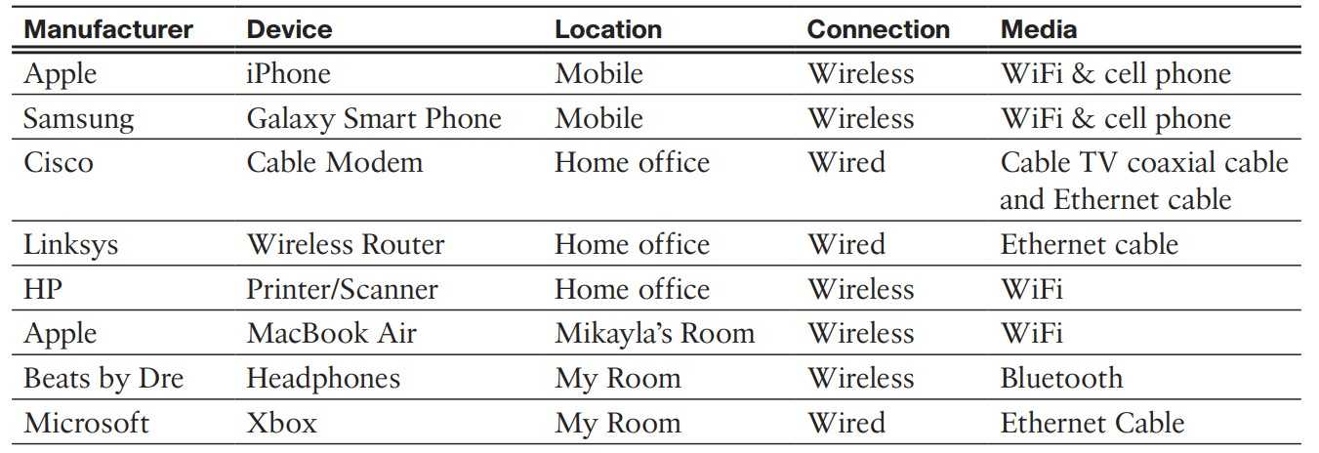

### Your Local Network

|  |  |  |  |  |
| --- | --- | --- | --- | --- |
| **Manufacturer** | **Device** | **Location** | **Connection** | **Media** |
| Samsung | Galaxy S23+ | Mobile | Wireless | Wifi & cell phone |
| Google | Home mini | My room | Wireless | Wifi |
| Govee | RGB light strip | My room | Wireless | Wifi |
| Tp-Link | Deco wireless router | Living room | Wired | Ethernet cable |
| Samsung | Galaxy buds | Mobile | Wireless | Wifi |
| Sony | PS4 | Living room | Wireless | Wifi |

Continue the list on a separate page if necessary.

## Reflection

1. Are there other electronic devices that are not connected to the local network to share information or resources? What would be the benefit of having these devices online?

Smart cooker. Connecting the smart cooker to the home network allows all family members to access built-in recipes on the smart cooker to assist in the cooking process.

1. Which type of connectivity is used most frequently in your local network, wired or wireless?

Wireless.

1. Draw a diagram of your local network. Label each device with a name and location.

Modem

Wireless Router

Home office:

* Home mini
* Galaxy buds
* RGB lights
* PS4

Switch

Mobile:

smartphone

**Sample**

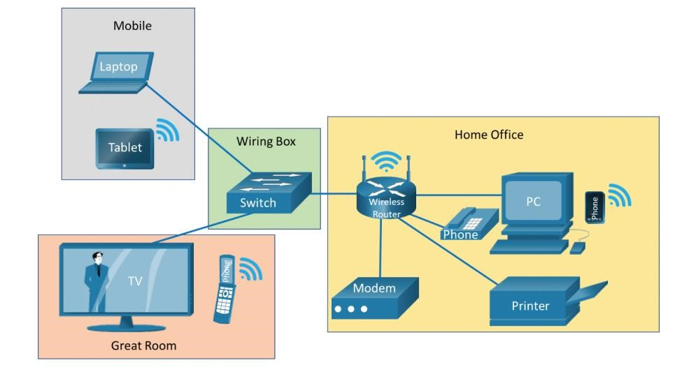

# Lab 1 – Part B - Determine the IP Address Configuration of a Computer

**Objectives**

❖ In this lab, you will determine the IP address assigned to your computer.

## Required Resources

* 1 PC/Laptop
* Network access

**Instructions**

## Part B.1: Determine the IP Address Using the Command Prompt

**Step 1:** Verify network access.

1. Open a web browser.
2. Navigate to any website, such as **www.netacad.com**.

**Step 2:** The command ipconfig.

The **ipconfig** (**ifconfig** on Mac)command provides you with the IP address, subnet mask and default gateway.

1. Click **Start**. Search for **Command Prompt**. Double-click to open a **Command Prompt**. (shortcut **Windows key + R**, then type in **cmd**).

1. At the prompt, enter **ipconfig** to determine the IP address assigned to each network adapter on your computer.

C:\Users\Student> **ipconfig**

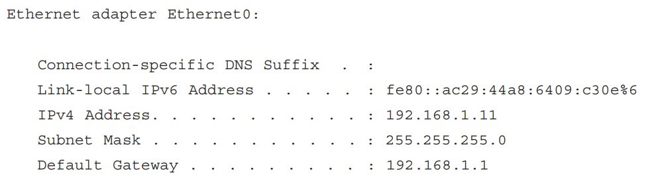

**Questions:**

What is the IPv4 address of the computer?

|  |
| --- |
| 172.20.29.253 |

What is the subnet mask of the computer?

|  |
| --- |
| 255.255.128.0 |

What is the default gateway of the computer?

|  |
| --- |
| 172.20.0.1 |

**Step 3:** The command **ipconfig /all**.

**a.** At the prompt, enter **ipconfig /all** command to view IP configuration on your PC.

C:\Users\Student> **ipconfig /all**

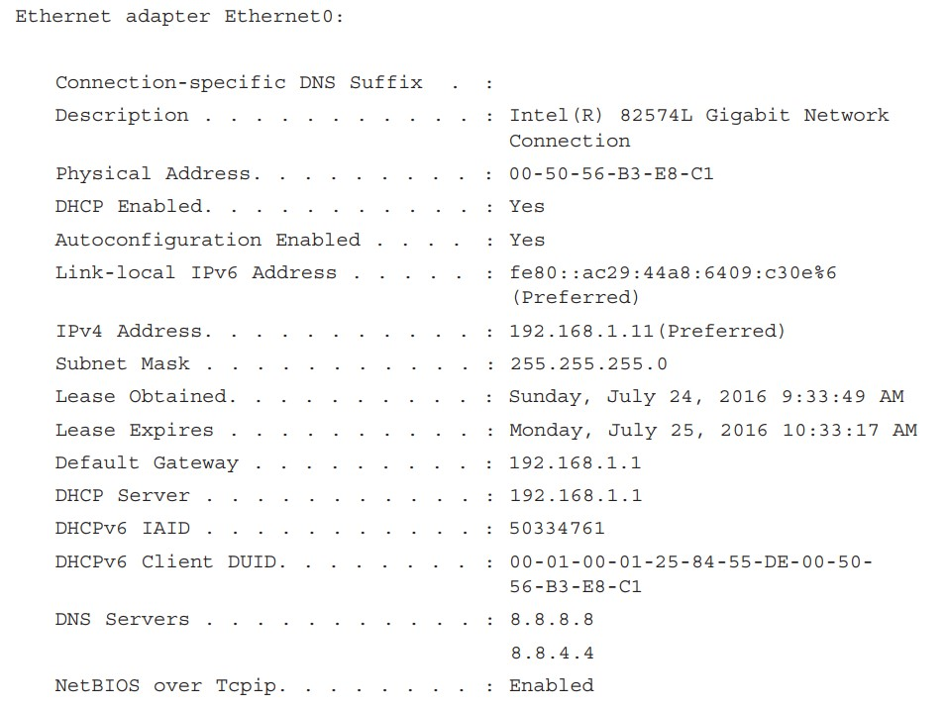

**Questions:**

What are the DNS servers for the computer?

|  |
| --- |
| 172.18.41.14  172.18.41.15 |

What is the MAC address (physical address) of the network adapter?

|  |
| --- |
| 78-2B-46-4C-F4-C3 |

Is DHCP enabled? If yes, what is the IP address of the DHCP server?

|  |
| --- |
| Yes. 172.18.41.14 |

If DHCP is enabled, on what date was the lease obtained? On what date does the lease expire?

|  |
| --- |
| Lease obtained: Tuesday, 6 February, 2024 12:24:34 PM  Lease expire: Tuesday, 6 February, 2024 2:49:48 PM |

## Part B.2: Test the Network Interface TCP/IP Stack

**Step 1:** Test TCP/IP stack using the loopback address.

To verify that the TCP/IP protocol is functioning, ping your loopback address (127.0.0.1). Enter the **ping 127.0.0.1** command at the prompt.

C:\Users\Student> **ping 127.0.0.1**

**Step 2:** Test TCP/IP stack using the configured IP address.

You can also ping **your IP address**. In this example, enter the **ping 192.168.1.11** command at the prompt.

**Question:**

Record one of the replies from your ping command.

|  |
| --- |
| Pinging 127.0.0.1 with 32 bytes of data: |

If the ping was not successful, ask your instructor for assistance.